**Getting Set Up for Day One**

1. Ensure that you have R and RStudio installed on your computer with the following versions:

* R: version 3.6.1 or later
* RStudio: version 1.2.1335 or later

1. Create a new RStudio project for the workshop.
   1. 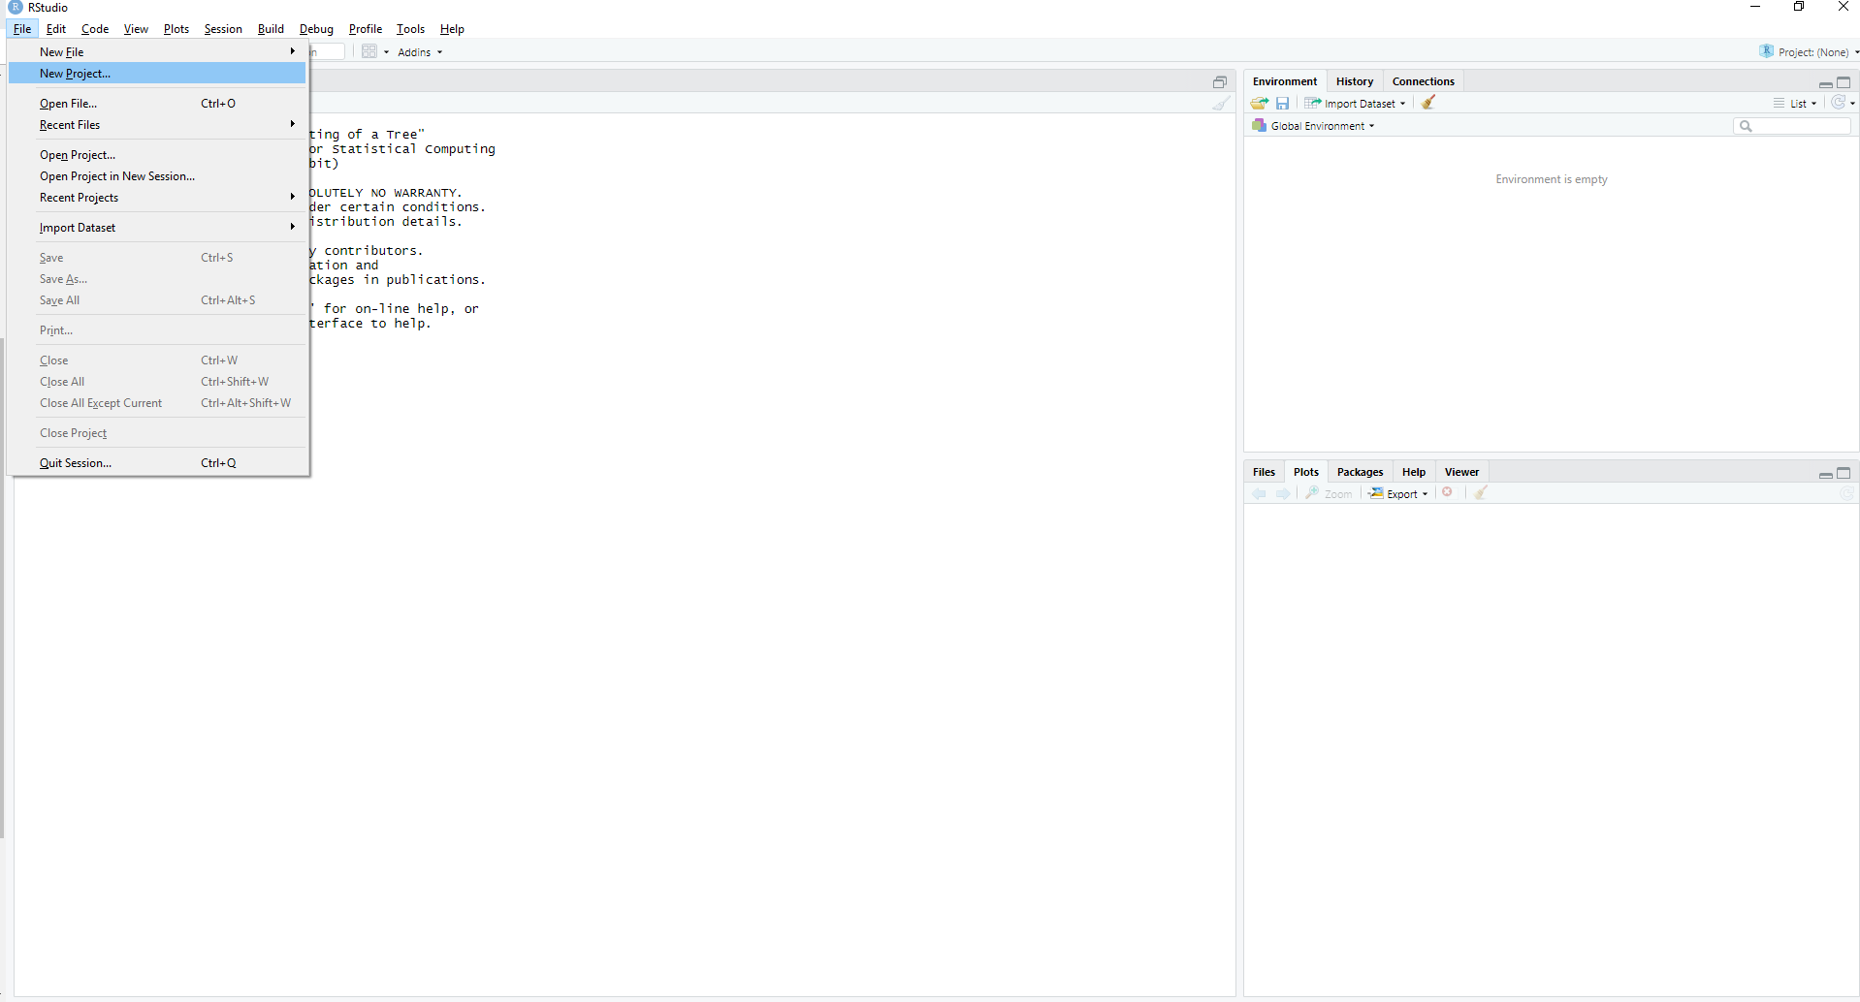While RStudio is open, navigate File -> New Project. This will open the “New Project” window.
   2. While in this window, navigate New Directory -> New Project.

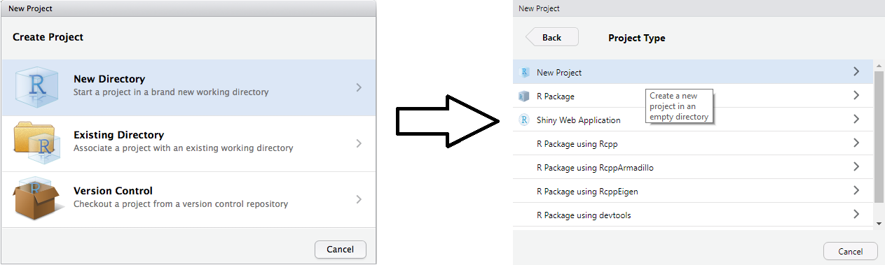

* 1. You will now have to name your project and choose a place on your computer for the project to be stored. Give the project a name that makes sense to you. For the purposes of this workshop store the project on your desktop. After you’ve done this click on Create Project.

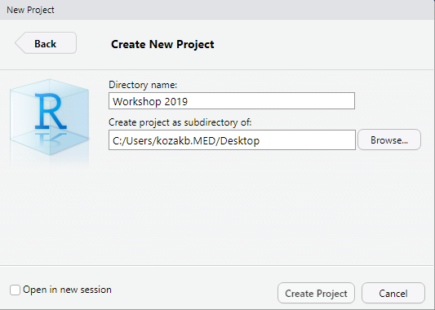

* 1. Return back to your desktop, you should now see a new folder that has the same name as the new project you created. Open the folder and verify that you have an R Project file inside.

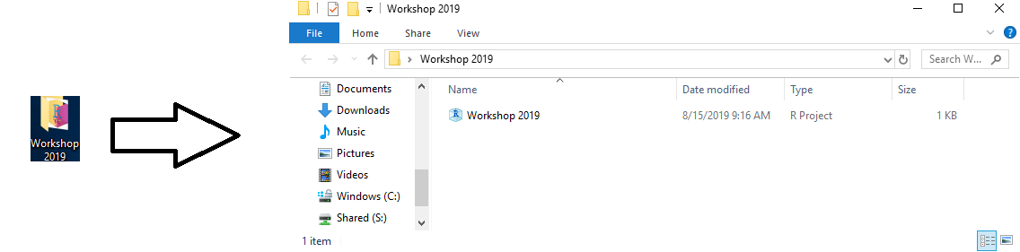

* 1. While inside the folder, create 4 new folders named (case sensitive):

- Data

- Documents

- Output

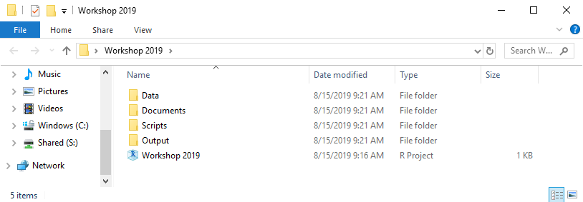- Scripts

1. Move all the workshop material that you’ve received via email into one of the above folders. For example, .csv and .xlsx files are likely to end up in the “Data” folder while .R files are likely to end up in the “Scripts” folder.
2. Running the test script
   1. While in RStudio, open the “getting_set_up.R” script.
   2. Before you run the script, ensure that you have the tidyverse package installed.
   3. In the scripting window, select all the code (Ctrl + A) and then click on “Run”
   4. 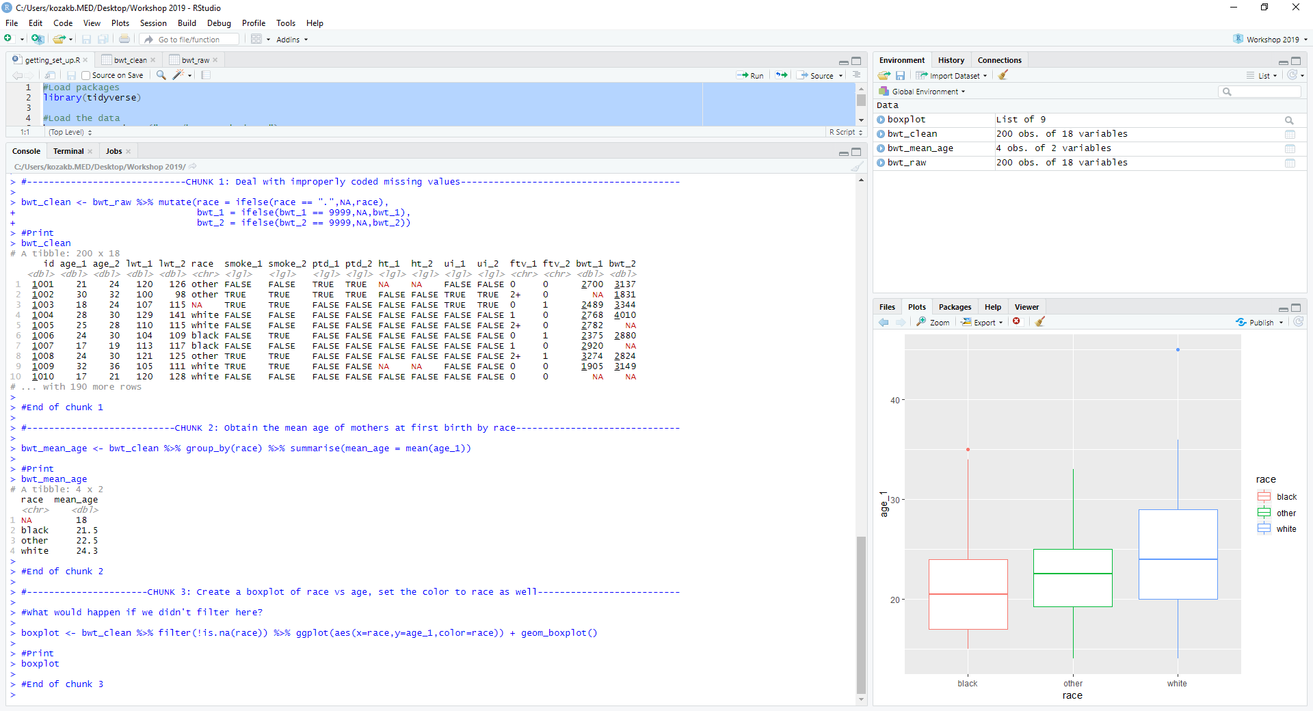After running the script, you should see the following.
3. Evaluate your knowledge in R by reading the code in the script.
   1. If you could have written the chunks just based on the prompts, then you have enough knowledge (plus more!) and will do extremely well in this workshop.
   2. If you could have started writing the code but may have needed some reminders, don’t sweat! This is normal and you will do just fine in this workshop.
   3. If any of the code in any of the chunks is completely foreign to you, you will need to brush up on coding in R using Tidyverse.
4. If you need resources to help you get ready for day one, consider reading R for Data Science. A free online copy is available here: <https://r4ds.had.co.nz/index.html>

* The most relevant sections for this workshop are:
  + 5.1-5.7 (filter(), arrange(), select(), mutate(), summarise(), piping)
  + 3.1-3.3 (ggplot)